Mystery over massive Alexander-era tomb unearthed in Greece
August 12, 2014 5:48 PM
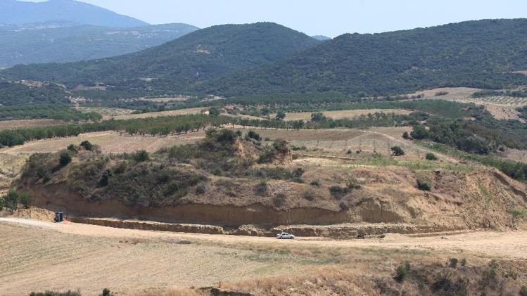
A view of a large burial monument dating back to the 4th century BC, in Kasta.
Athens (AFP) - Archaeologists have unearthed a funeral mound dating from the time of Alexander the Great and believed to be the largest ever discovered in Greece, but are stumped about who was buried in it.
Prime Minister Antonis Samaras on Tuesday described the find as "unique" after he visited the site, which dates to the era following Alexander's death, at the ancient town of Amphipolis in northern Greece.
"It is certain that we stand before an exceptionally important find," Samaras said in a statement. "This is a monument with unique characteristics."
Hidden under a hill at the ancient town, the Hellenistic-era mound containing the tomb has a near-circular circumference of 497 metres (1,630 feet), Samaras said.
A five-metre marble lion, currently standing on a nearby road, originally topped the tomb, he said.
"The tomb is definitely dated to the period following the death of Alexander the Great (in 323 BC), but we cannot say who it belonged to," supervising archaeologist Katerina Peristeri told Mega channel.
Built on the banks of the river Strymon, some 60 kilometres (37 miles) from the modern city of Serres, Amphipolis was an important city of the ancient Macedonian kingdom under Alexander.
Alexander's Persian wife Roxanne and son Alexander were exiled to Amphipolis and murdered there on the orders of his successor King Cassander around 310 BCE.
There were no suggestions that the tomb could have belonged to Alexander himself, who died in Babylon in what is present-day Iraq, but experts believe it could have belonged to another member of the royal family
http://news.yahoo.com/mystery-over-massive-alexander-era-tomb-unearthed-greece-214827708.html

